LAB Manual

PART A

(PART A : TO BE REFFERED BY STUDENTS)

**Experiment No.05**

PART B

(PART B : TO BE COMPLETED BY STUDENTS)

|  |  |
| --- | --- |
| Roll No.: C026 | Name: Anirbaan Ghatak |
| Class : B | Batch : B1 |
| Date of Experiment: | Date of Submission |
| Grade : | Time of Submission: |
| Date of Grading: |  |

**B.1 Software Code written by student:**

# Name: Anirbaan Ghatak

# Roll no: C026

# Aim:To write a program to enhance the quality of an image by noise removal.

import numpy as np

import cv2 as cv

from google.colab.patches import cv2_imshow

img = cv.resize(cv.imread('asdfjk.jpg'), (256, 256))

def showImage(img):

    cv2_imshow(img)

    cv.waitKey(0)

    cv.destroyAllWindows()

grayImg = cv.cvtColor(img, cv.COLOR_BGR2GRAY)

showImage(grayImg)

h2 = np.array([[1, 1], [1, -1]])

h = h2.copy()

for i in range(7):

    h = np.kron(h, h2)

hT = np.transpose(h)

hadamard = np.dot(np.dot(h, grayImg), hT).astype(np.uint8)

showImage(hadamard)

inverse = np.dot(np.dot(h, hadamard), hT)/(256**2)

showImage(inverse.astype(np.uint8))

rc = dict()

for i in range(len(h)):

    change = 0

    x = 1

    for j in h[i]:

        if x != j:

            x = j

            change += 1

    rc[i] = change

sort = sorted(rc.items(), key=lambda kv:

              kv[1])

walsh=h.copy()

for i in range(len(walsh)):

    index=sort[i][0]

    walsh[i]=h[index]

walsh=walsh.astype(np.uint8)

showImage(walsh)

walshT=np.dot(np.dot(walsh,grayImg),np.transpose(walsh)).astype(np.uint8)

showImage(walshT)

inverseWalsh=np.dot(np.dot(walsh,walshT),np.transpose(walsh))//(255**2)

showImage(inverseWalsh.astype(np.uint8))

**B.2 Input and Output:**

**Input Images:**

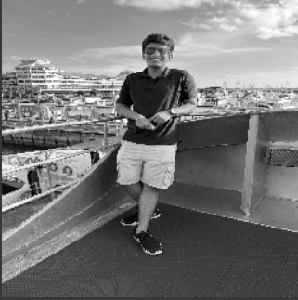

**Output Images:**

1. **For each Transform (Hadamard, Walsh ) as per the procedure discussed in section A.5.**

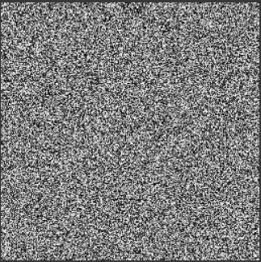

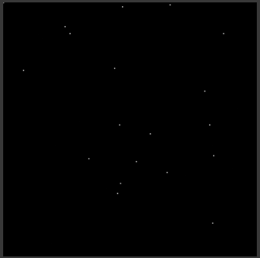

**b.**

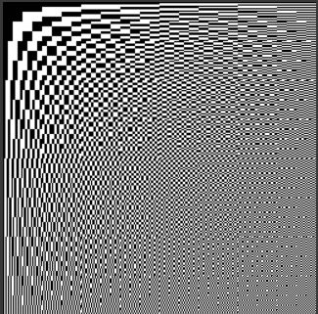



**B.3 Observations and learning:**

*Understand the fundamentals of Hadamard, and Walsh Transforms and its effects on digital images along with its different properties. Using python Hadamard and Walsh Transform were applied to an image and verified its correctness. Learned and Identified application of transform studies.*

**B.4 Conclusion:**

*Implemented Hadamard and Walsh Transform for the selected image to see the transformation and verify its correctness.*

**B.5 Question of Curiosity**

***(To be answered by student based on the practical performed and learning/observations)***

Q1: What are the applications of each of these transforms you have studied?

Hadamard Transform is applied in several ways, including:

**Image Compression:** The Hadamard Transform is used to compress digital images by converting them into a more compact representation. This helps reduce file sizes for efficient storage and transmission while preserving essential image information.

**Image Enhancement:** It can enhance image quality by emphasizing certain image features or reducing noise through frequency domain analysis. This is valuable in improving the visual quality of images.

**Image Encryption:** The Hadamard Transform can be incorporated into image encryption techniques to secure sensitive visual data during transmission or storage.

Welsh Transform is applied in several ways:

**Texture Analysis:** The Walsh Transform can be used for texture analysis in images, helping to identify and classify different textures within an image. This can be valuable in fields like remote sensing and geological imaging.

**Edge Detection:** It can be employed for edge detection in images, assisting in identifying boundaries and edges between different objects or regions within the image.

**Image Analysis in Biomedicine:** In some biomedical imaging applications, the Walsh Transform can be used for feature extraction and analysis.

************************